Week Review 4

Math

Vocabulary and Examples:

Greatest Common Factor- Factors are numbers we can multiply together to get another another. For example 2 and 3 are factors of 6. 1 and 6 are also factors of 6. Prime numbers have only themselves and 1 as a factors. Composite numbers have more than 1 and themselves. When looking at the factors of two numbers, if they have any in common, those numbers are common factors. The greatest common factor is the largest factor that those numbers share.

Example:

Find the greatest common factor for 12 and 20.
Factors of 12: 1,2,3,4,6,12
Factors of 20: 1,2,4,5,10

Greatest Common Factor: 4

Least Common Multiple- Multiples can be determined by skip counting, or by multiplying the number of interest by another number (just not 0). For example the multiples of 5 are 5, 10, 15, 20, 25, 30…. When looking at the multiples of two numbers, the first number they have in common is the least common multiple.

Example:

Find the least common multiple for 6 and 4

Multiples of 6: 6, 12, 18, 24, 30, 36
Multiples of 4: 4, 8, 12, 16, 20, 24, 28, 32, 36

Least Common Multiple: 12 (note: 24 and 36 are common multiples, but the least common multiple is the smallest number they have in common).

Questions

Part A:

Find Greatest Common Factor for:
- 8 and 6 b) 12 and 16 c) 10 and 20
Find Lowest Common Multiple for:
- 2 and 3 c) 4 and 5 d) 2 and 5

Part B:

Find Greatest Common Factor for:
- 51 and 27 b) 99 and 66 c) 48 and 60
Find the Lowest Common Multiple for:
- 9 and 7 b) 10 and 4 c) 12 and 13

Part C:

Beginning at 8:30 A.M, tours of House of Commons and the Senate begin at a tour agency. Tours for the House of Commons leave every 15 minutes. Tours for the Senate leave every 20 minutes. How often do the tours leave at the same time?

The table shows the number of students in the school choir. The choir teacher plans to arrange the students in equal rows. Only girls or boys will be in each row. What is the greatest number of students that could be in each row?

Students | Number
Boys | 48
Girls | 64

Subtraction Review:

- 3.45 +7+ 0.003 b) 3.405 + 7 c) 34.05 + 7.1 d) 340.5 + .71

Algebra Review- Solve for M
- M + 5 = 10 b) 2 + 4 + 7 = M + 8 + 1 c) 48 ÷ M = 6 d) 100 ÷ M = 48 + 2

Science

Using the Nitrogen Cycle, explain how the nitrogen moves through the system depicted in the diagram below:

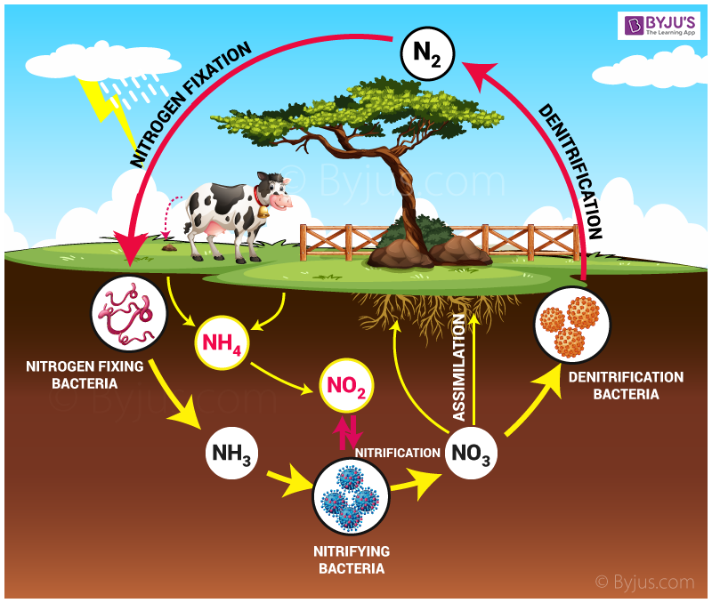

Draw a tree, and label the 4 levels of a forest.

Social Studies

Define the following words in terms of Parliament. (Bonus: Find out who is currently in those positions)
- Independent
- Leader of the Opposition
- Speaker of the House of Commons
- The Cabinet
- Premier

Why does it take so many steps to pass a Bill to make a new law in Parliament?

Grammar (this is front loading for an activity next week)

Sentences have dependent and independent clauses:
Independent- “I learned a lot about complex sentences”
Dependent- “...while listening to the teacher.”

Put them together: “I learned a lot about complex sentences, while listening to the teacher.”

Write independent clauses to start the sentence for the following dependent clauses:

“...before it starts to rain.”
“...after the wolves showed up.”
“...while the snowman melted away.”

